RPYT 10 Day Retreat Course Agenda

Cost: $10,000
*Includes healthy food, accommodations, excursions.
*Excludes airfare.

Location: Kona, Hawaii

Dates: Monday, April 10 to Wednesday, April 19, 2022

*85 Hours of Instruction on Prenatal Yoga for the Yoga Alliance Accredited RPYT Degree.

*9 Class Days.

*5 Hours per Day Live (Exception, Day 5 is a Half Day with 2.5 Hours Live).

*Remaining 42.5 Hours are denoted with this 📽 icon and are Self-Paced/Pre-Recorded Lectures available for download and viewable while we are en route to incredible excursions throughout the island.

*Average of 10 hours of study Days 1-9 except 5 hours on Day 5.

*Day 10 is Departure Day.

Day 1: General Background in Specialty Area & Prenatal Yogic Philosophy- 10 Hours

Part 1- Yoga Alliance Requires 5 Hours of general background in subject area - each number below represents one hour.
- Meet the instructor
  - Explain experience with prenatal yoga as a teacher
  - Explain liability waiver (see handout)
  - Explain disclosure of pregnancy or health conditions (see handout)
  - Explain letter to prenatal clients (see manual)
- general background of prenatal yoga
  - (see handout 1, approaches to yoga),
  - discuss application of Kirpalu lineage
- Benefits of prenatal yoga (see blog of this title)
  - Increased flexibility
  - Enhanced strength and resilience
  - Improved balance
  - Greater ability to concentrate
  - Improved breathing and lung capacity
  - Increased body awareness and self image
  - Reduces stress
  - See blogs re benefits of yoga for inmates and discuss prenatal prison yoga benefits
- Differentiating betweenHigh Risk and Non-High Risk Pregnancy
  - See 1st trimester blog
  - See 2nd trimester blog
  - See 3rd trimester blog
- Creating a Safe Studio Environment
  - Discuss cleaning protocols, vaccines, vaccine waivers and disclosures
  - Loud noises and how they effect pregnancy
  - Smell sensitivity for pregnant women
  - Stairs and accessibility to studio issues

Part 2- Philosophy, Lifestyle, Ethics
*Yoga Alliance requires 5 hours in this subject matter.
*This material is pre-recorded

Each point below represents one hour of the remaining 10 hours of Day 1.
- 📽Review of Key Sutras of Patañjali
- 📽Review of Major Yogic Texts: The Bhagavad Gita
- 📽Review of the 8 Limbs of Yoga
- 📽Origins of Yoga
- 📽Yoga Foundations - explaining the various Yoga styles and philosophies including:
  - Ananda,
  - Anusara,
  - Asthanga,
  - Bikram,
  - Integral,
  - Iyengar,
  - Kripalu (our school),
  - Kundalini,
  - Sivananda,
  - Svaroopa
  - Viniyog

Day 2: Teaching Methodology - 10 Hours
*Yoga Alliance requires 10 hours in this subject matter.

Each number represents an hour:
- 📽Teaching Methodologies for First Trimester Beginner Yoga Students
- Teaching Methodologies for Second Trimester Beginner Yoga Students
- Teaching Methodologies for Third Trimester Beginner Yoga Students
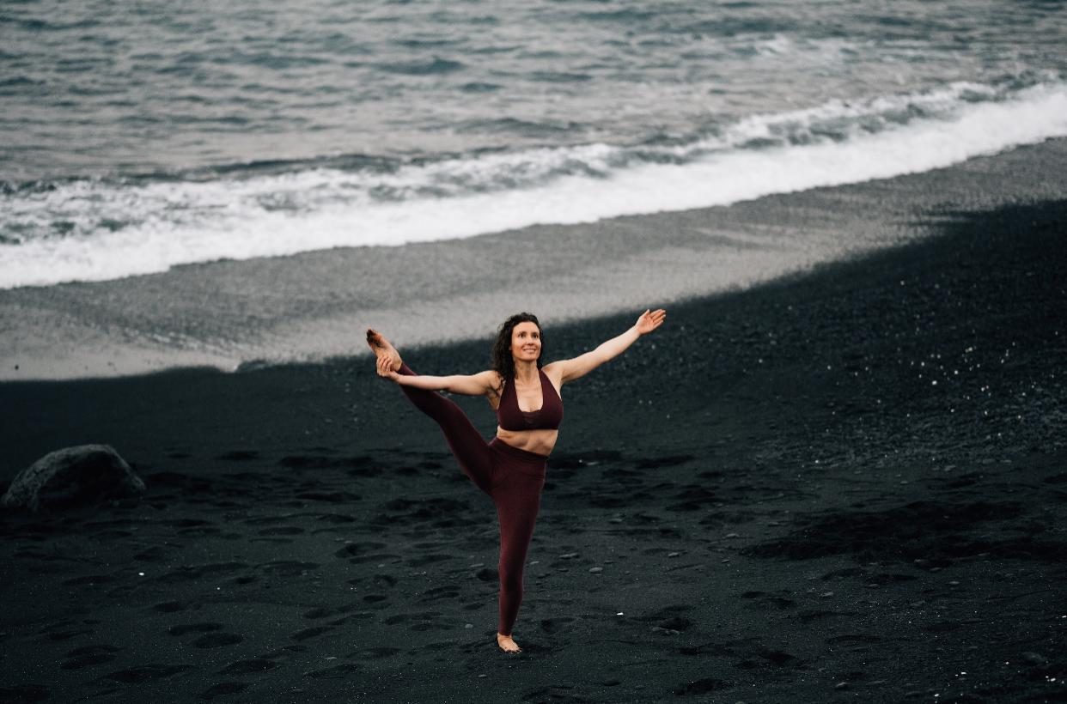
- Teaching Methodologies for First Trimester Advanced Yoga Students
- Teaching Methodologies for Second Trimester Advanced Yoga Students
- Teaching Methodologies for Third Trimester Advanced Yoga Students
- 📽Class Management
  - Overview (10 minutes)
  - Tips and troubleshooting
  - Prenatal waivers and disclosures
  - Identifying when medical advice is needed
  - How to set boundaries and maintain safety
  - Summary of Key Class Management Points
- 📽Environment
  - Environment for First Trimester Beginner Yoga Students (10 minutes)
  - Environment for Second Trimester Beginner Yoga Students
  - Environment for Third Trimester Beginner Yoga Students
  - Environment for First Trimester Advanced Yoga Students
  - Environment for Second Trimester Advanced Yoga Students
  - Environment for Third Trimester Advanced Yoga Students
- 📽Pace of Class
  - Pace for First Trimester Beginner Yoga Students (10 minutes)
  - Pace for Second Trimester Beginner Yoga Students
  - Pace for Third Trimester Beginner Yoga Students
  - Pace for First Trimester Advanced Yoga Students
  - Pace for Second Trimester Advanced Yoga Students
  - Pace for Third Trimester Advanced Yoga Students
- 📽Cueing
  - Verbal Cueing (10 minutes)
  - Visual Cueing (10 minutes)
  - Physical Cueing (10 minutes)
  - Cueing for the first trimester (10 minutes)
  - Cueing for the second trimester (10 minutes)
  - Cueing for the third trimester (10 minutes)

Days 3 Prenatal Techniques, Training & Practice - 10 hour class session
*Yoga alliance requires 25 hours in this subject matter.

Each number represents an hour:
- Pranayama - Introduction to Prenatal Breathing
- Pranayama for the first trimester
- Pranayama for the second trimester
- Pranayama for the third trimester
- Pranayama- Check your knowledge with quiz questions and answers
- 📽Meditation- Introduction to Prenatal Meditation and Incarcerated Prenatal Meditation
- 📽Meditation for the first trimester
- 📽Meditation for the second trimester
- 📽Meditation for the third trimester
- 📽Sample Meditations

Days 4 Prenatal Techniques, Training & Practice - 10 hour class session
*Yoga alliance requires 25 hours in this subject matter.

Each number represents an hour:

- Asanas for the second trimester- Intro [see YA detail]
- Asanas for the second trimester- seated poses [see YA detail]
- Asanas for the second trimester- standing poses [see YA detail]
- Asanas for the second trimester- balancing poses [see YA detail]
- Asanas for the second trimester- restorative poses [see YA detail]
- 📽Asanas for the first trimester- Intro [see YA detail]
- 📽Asanas for the first trimester- seated poses [see YA detail]
- 📽Asanas for the first trimester- standing poses [see YA detail]
- 📽Asanas for the first trimester- balancing poses [see YA detail]
- 📽Asanas for the first trimester- restorative poses [see YA detail]

Days 5- Prenatal Techniques, Training & Practice - 5 hour class session - half day - catch up session break mid-semester
*Yoga alliance requires 25 hours in this subject matter.

Each number represents an hour:

- Asanas for the third trimester-
  - Introduction
  - seated poses
  - Standing poses
  - Balancing poses
  - Props
  - Modifications
- Asanas for the third trimester- restorative poses
- 📽Asanas for the third trimester- sample class 1
- 📽Asanas for the third trimester- sample class
- 📽Asanas for the third trimester- sample class 3

Days 6- Prenatal Anatomy & Physiology - 10 hour session
*Yoga alliance requires 10 hours in this subject matter.

Each number represents an hour:
- Overview of Female Anatomy
  - coloring handout - learn the physical anatomy of the female reproductive system - overview (10 minutes)
  - Explain how to fill out handout (10 minutes)
  - Class time to complete handout (10 minutes)
  - Review handout answers (10 minutes)
  - Discuss relevance of handout for prenatal yoga (10 minutes)
  - Review key takeaways from handout (10 minutes)
- Internal Female Organs
  - Cervix (10 minutes)
  - Fallopian Tubes (10 minutes)
  - Ovaries (10 minutes)
  - Uterus (10 minutes)
  - Urethra (10 minutes)
  - Vagina (10 minutes)
- External Female Organs
  - Mons pubis (10 minutes)
  - Pudendal cleft (10 minutes)
  - Labia majora (10 minutes)
  - Labia minora (10 minutes)
  - Bartholin’s Glands (10 minutes)
  - Clitoris (10 minutes)
- Physiology
  - Overview- yoga helps anxiety blog handout- (10 minutes)
  - Hormonal Changes (see prenatal supplement) (10 minutes)
  - Blood volume (10 minutes)
  - Weight Gain (10 minutes)
  - Increase in Fetus Size (10 minutes)
  - Renal changes (10 minutes)
- The Systems in the Human Body - Part 1
  - Digestive System (10 minutes)
  - Respiratory System (10 minutes)
  - Nervous system (10 minutes)
  - Cardiovascular System (10 minutes)
  - Circulatory System (10 minutes)
  - Endocrine System (10 minutes)
- 📽The Systems in the Human Body- Part 2
  - skeletal system (10 minutes)
  - urinary system (10 minutes)
  - muscular System (10 minutes)
  - immune System (10 minutes)
  - reproductive System (10 minutes)
  - integumentary System (10 minutes)
- 📽Major Bones (handout number 5)
  - Major bones portion of handout - overview (10 minutes)
  - Explain how to fill out handout (10 minutes)
  - Class time to complete handout (10 minutes)
  - Review handout answers (10 minutes)
  - Discuss relevance of handout for prenatal yoga (10 minutes)
  - Review key takeaways from handout (10 minutes)
- 📽Major Muscles (handout number 5)
  - Major bones portion of handout - overview (10 minutes)
  - Explain how to fill out handout (10 minutes)
  - Class time to complete handout (10 minutes)
  - Review handout answers (10 minutes)
  - Discuss relevance of handout for prenatal yoga (10 minutes)
  - Review key takeaways from handout (10 minutes)
- 📽Biomechanics, Contraindications, Modifications and Safety- Part 1 (discuss sun salutation A for pregnancy and first set of yoga poses with respect to prenatal anatomy)
  - Sun A + discussion of each pose in Sun A (10 minutes)
  - Poses 1-20 (50 minutes)
- 📽Biomechanics, Contraindications, Modifications and Safety- Part 2 (discuss sun salutation A for pregnancy and second set of yoga poses with respect to prenatal anatomy)
  - Prenatal Anatomy of Poses 21-41and recommended variations (30 minutes)
  - Poses Anatomy of Poses 41-45 and recommended variations (20 minutes)
  - Anatomical support for prenatal savasana and prenatal savasana variations (10 minutes)

Days 7- Elective - 10 hour session
*Yoga alliance requires 10 hours in this subject matter.

Each number represents an hour:
- Partner yoga Introduction
  - Overview - What will you learn (10 minutes)
  - Benefits - how will you use it (10 minute)
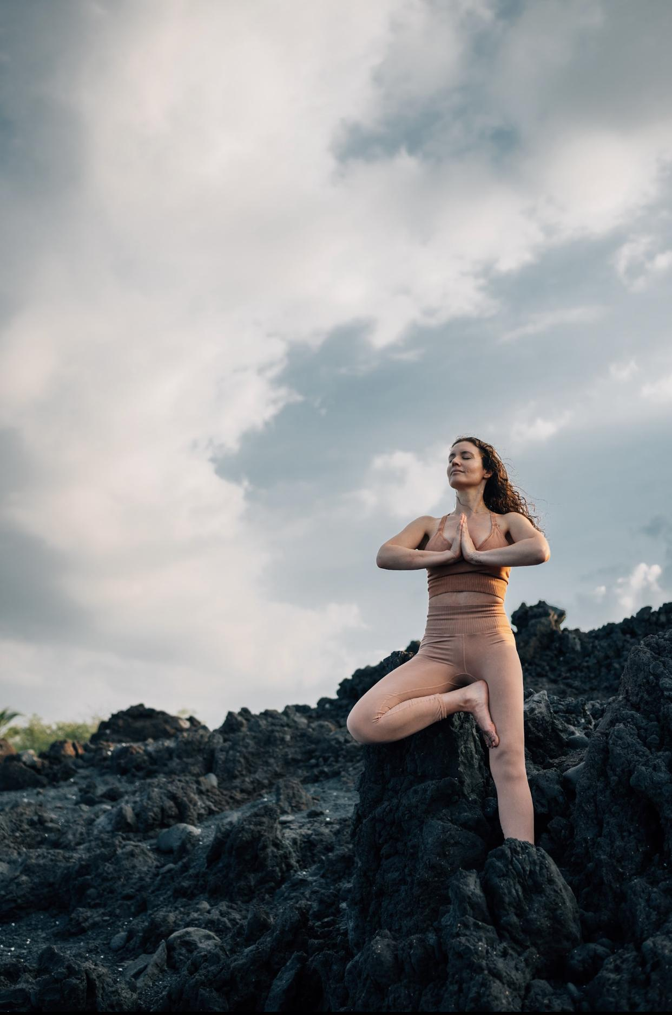
  - Equipment- what do you need (10 minutes)
  - Safety Considerations (10 minutes)
  - Standard modifications overview (10 minutes)
  - Guidelines by trimester (10 minutes)
- Partner Yoga Breathing
  - Overview (10 minutes)
  - First trimester partner breathing (10 minutes)
  - Second trimester partner breathing (10 minutes)
  - Third trimester partner breathing (10 minutes)
  - Labor and delivery partner breathing (10 minutes)
  - Review of partner breathing (10 minutes)
- Partner Postures- Part 1
  - Partner back to back or seated movements overview
  - Partner Warrior 2
  - Partner Reverse Warrior
  - Partner Warrior 3
  - Back to back triangle
  - Partner simple standing back bend
- Partner Postures- Part 2
  - Review of Partner Postures Part 1 (10 minutes)
  - Partner Sit (10 minutes)
  - Partner Tree Pose (10 minutes)
  - Partner Cobbler’s Pose (10 minutes)
  - Partner Chest Opener Variation of Cobbler’s Pose (10 minutes)
  - Partner Seated Twist (10 minutes)
- Chair Yoga
  - Introduction/Benefits (10 minutes)
  - Formation of Practice - how to structure your chair yoga practice (10 minutes)
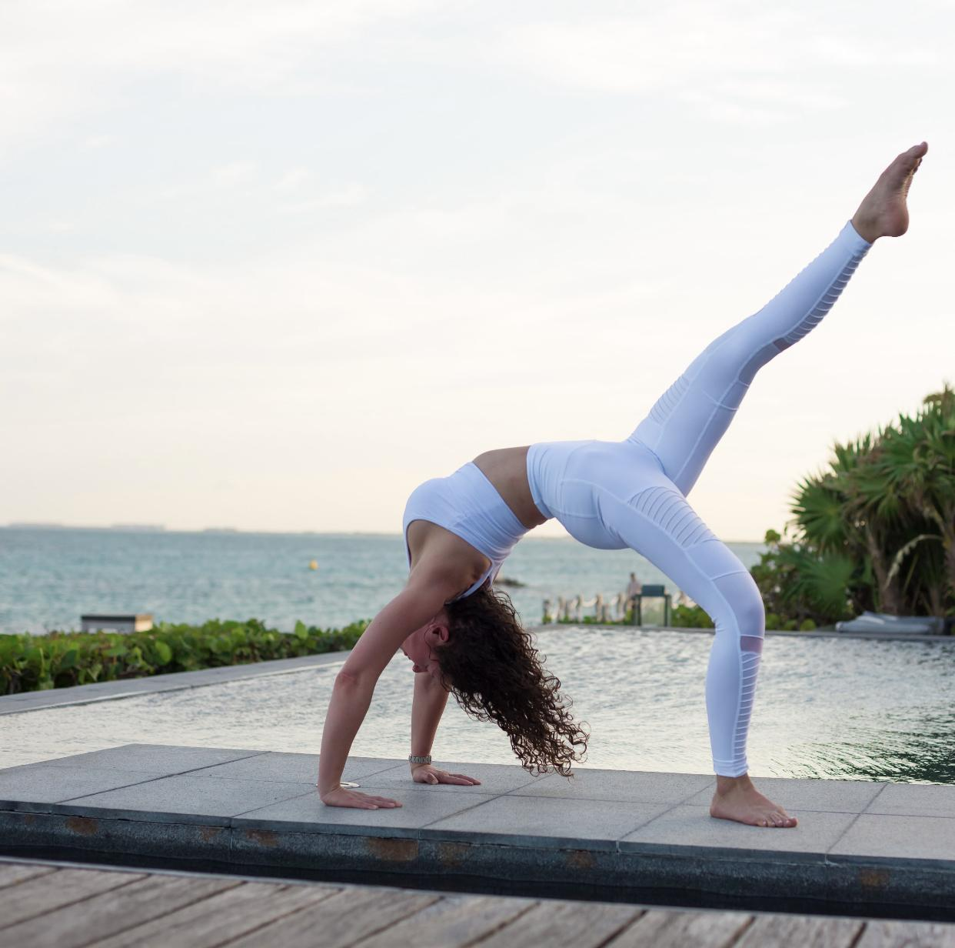
  - Overview of chair yoga postures (10 minutes)
  - Overview of chair yoga sequences (10 minutes)
  - Chair yoga warm ups (10 minutes)
  - Key Points of Chair Yoga for Prenatal Clients by trimester (10 minutes)
- 📽Chair Yoga Breathwork
  - Alternate nostril breathing (10 minutes)
  - Chair yoga breathwork for first trimester (10 minutes)
  - Chair yoga breathwork for second trimester (10 minutes)
  - Chair yoga breathwork for third trimester (10 minutes)
  - The respiratory system from a seated position (10 minutes)
  - Key Points of chair yoga breathwork (10 minutes)
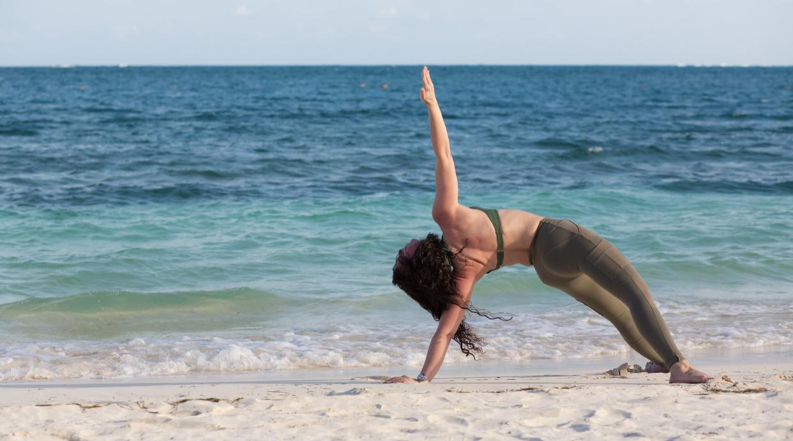
- 📽Chair Yoga Sun Salutation
  - Overview (10 minutes)
  - Pose by pose breakdown (10 minutes)
    - Inhale arms up
    - Exhale forward fold
    - Inhale lift chest
    - Exhale forward fold
    - Inhale reach arms up
    - Exhale hands to heart
  - Sun A (10 minutes)
  - Sun B (10 minutes)
  - Variations (10 minutes)
  - Key points of chair yoga sun salutations
- 📽Chair Yoga poses part 1
  - Cat/cow (10 minutes)
  - Chair warm up twist
  - Chair Warrior 3
  - Chair half moon
  - Chair arm balance
  - Review of chair poses part 1 (10 minutes)
- 📽Chair yoga poses part 2
  - Chair crescent stretch (10 minutes)
  - Chair Eagle (10 minutes)
  - Chair pigeon
  - Chair sun worshiper
  - Chair straddle fold
  - Review of chair poses part 2 (10 minutes)
- 📽Chair Yoga poses part 3
  - Chair hamstring stretch (10 minutes)
  - Chair leg lift
  - Chair cows face
  - Chair locust pose
  - Chair spinal twist
  - Review of all chair poses (10 minutes)

Days 8- Class Observations/Teaching Practicum - 10 hour session
*Yoga alliance requires 20 hours in this subject matter.

Students Observe a class and then teach a class in alternating hours.
- 5 hours of teaching practice of first and second trimester focused classes [ADD YA]
- 📽5 hours of class observations of first and second trimester focused classes

Days 9- Class Observations/Teaching Practicum - 10 hour session
*Yoga alliance requires 20 hours in this subject matter.
*Graduation: RPYT Certificates will be awarded to those who earned their degree.

Students Observe a class and then teach a class in alternating hours.
- 5 hours of teaching practice of first and second trimester focused classes [ADD YA]
- 📽5 hours of class observations of first and second trimester focused classes

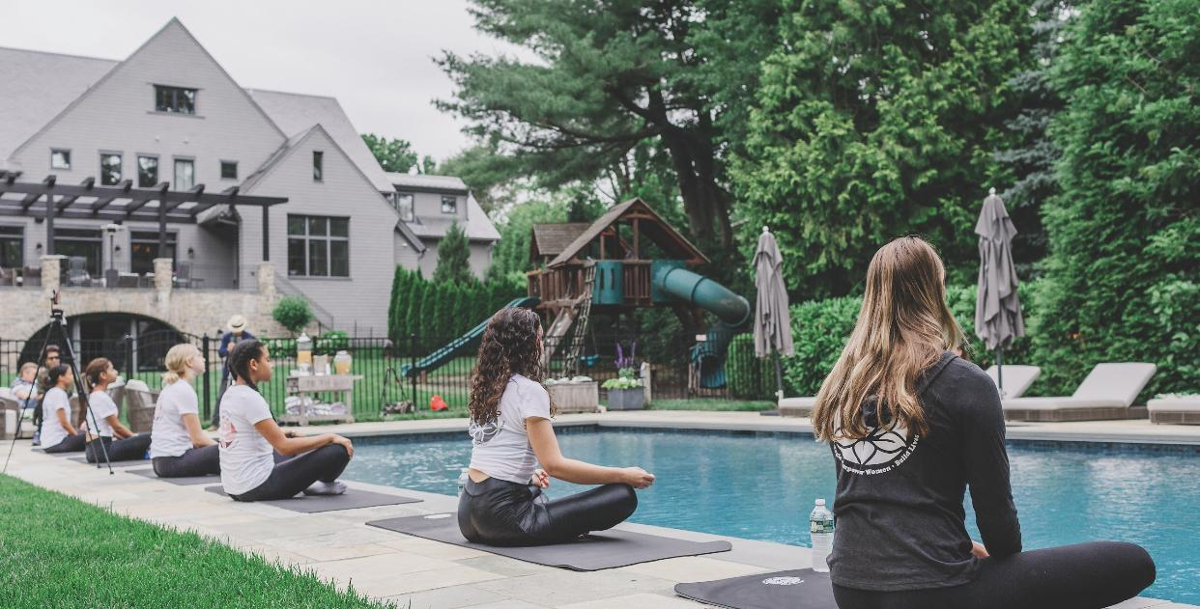
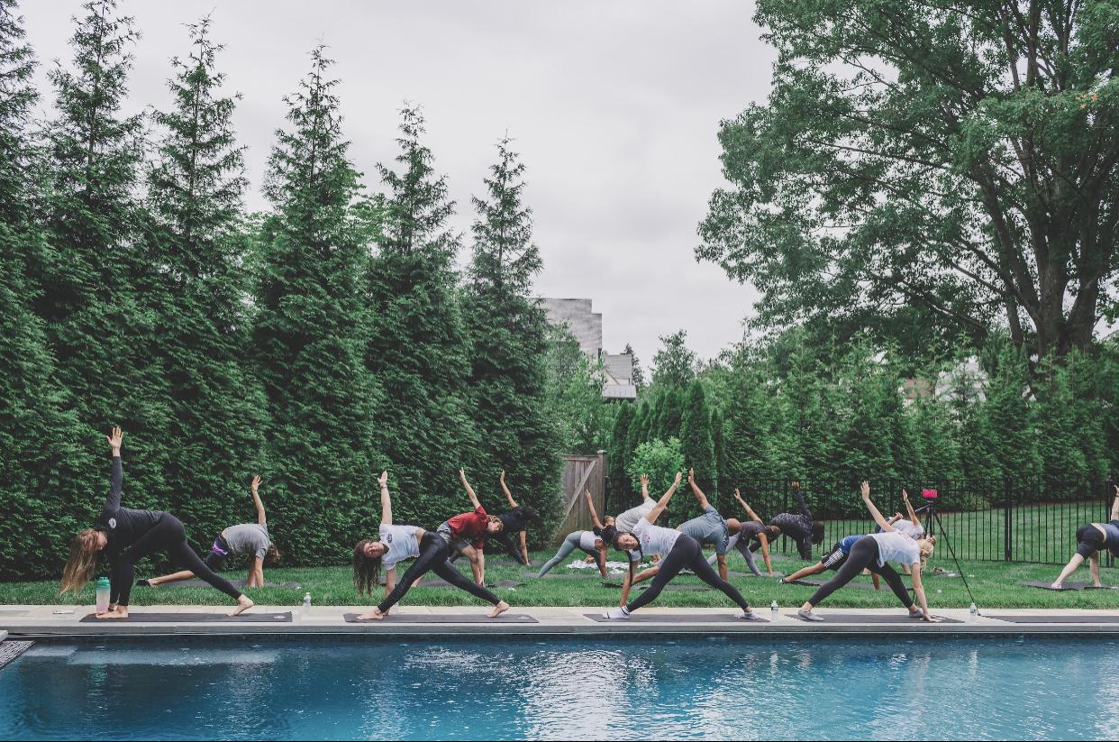

Day 10 - Departure Day
*Exchange Contact Information with New Friends that are Now Your Yoga Teacher Colleagues!

